CAN THO UNIVERSITY

COLLEGE OF INFORMATION AND COMMUNICATION
TECHNOLOGY



GRADUATION THESIS
BACHELOR OF ENGINEERING IN
INFORMATION TECHNOLOGY
(HIGH-QUALITY PROGRAM)

BUILDING AN ADMISSION CONSULTING CHATBOT FOR CAN THO UNIVERSITY

Student: Nguyen Van Thuan
Student ID: B2112012
Class: 2021 – 2025
Advisor: Dr. Thai Minh Tuan

Can Tho, 8/2025

CAN THO UNIVERSITY

COLLEGE OF INFORMATION AND COMMUNICATION
TECHNOLOGY

GRADUATION THESIS
BACHELOR OF ENGINEERING IN
INFORMATION TECHNOLOGY
(HIGH-QUALITY PROGRAM)

BUILDING AN ADMISSION CONSULTING CHATBOT FOR CAN THO UNIVERSITY

Student: Nguyen Van Thuan
Student ID: B2112012
Class: 2021 – 2025
Advisor: Dr. Thai Minh Tuan

Can Tho, 8/2025

EVALUATION OF ADVISOR
......................................................................................................................................
......................................................................................................................................
......................................................................................................................................
......................................................................................................................................
......................................................................................................................................
......................................................................................................................................
......................................................................................................................................
......................................................................................................................................
......................................................................................................................................
......................................................................................................................................
......................................................................................................................................
......................................................................................................................................
......................................................................................................................................
......................................................................................................................................
......................................................................................................................................
......................................................................................................................................
......................................................................................................................................
......................................................................................................................................
......................................................................................................................................
......................................................................................................................................

Advisor

Thai Minh Tuan

ACKNOWLEDGEMENTS
First and foremost, I would like to express my deepest gratitude to my parents for their unconditional love, understanding, and patience throughout my academic journey. Without their unwavering support, this achievement would not have been possible.
Next, I want to thank myself for the constant effort and determination in overcoming the challenges faced throughout this research and thesis writing process. It is through my relentless dedication that I have been able to complete this work.
Finally, I would like to express my sincere thanks to my supervisor, Dr. Thai Minh Tuan, for his invaluable guidance, continuous support, and encouragement throughout the entire process of this thesis. His expert advice and insightful feedback were instrumental in shaping this research and helping me overcome many obstacles.
I am grateful to the faculty and staff at Can Tho University for their assistance in providing relevant data, resources, and a conducive research environment, which greatly contributed to the smooth progress of this project.
Special thanks to my colleagues and friends who have shared their knowledge, experience, and motivated me during difficult times. Their moral support played a crucial role in maintaining my enthusiasm and perseverance.
Can Tho / / 2025

Nguyen Van Thuan

TABLE OF CONTENTS
EVALUATION OF ADVISOR i
ACKNOWLEDGEMENTS ii
LIST OF ABBREVIATIONS v
LIST OF FIGURES vi
LIST OF TABLES vii
ABSTRACT viii
INTRODUCTION 1
PROBLEM STATEMENT 1
RESEARCH OBJECTIVES 2
SCOPE OF THE RESEARCH 2
CHAPTER 1 - OVERVIEW 4
1.1 THE CRITICAL NEED FOR ADMISSIONS COUNSELING AT CAN THO UNIVERSITY 4
1.1.1 The Need for Comprehensive, Accurate, and Current Information 4
1.1.2 The Demand for Accuracy and Currency 4
1.2. CURRENT STATE OF ADMISSIONS COUNSELING SOLUTIONS AT CAN THO UNIVERSITY 5
1.2.1. The Official University Portal 5
1.2.2. Direct Interaction Channels 5
1.2.3. Social Media Channels 6
1.2.4. Media Events and Direct Counseling 6
1.3. OVERALL ASSESSMENT AND THE IDENTIFIED SERVICE GAP 6
1.4. CHATBOTS: TECHNOLOGICAL FOUNDATIONS AND STRATEGIC APPLICATIONS IN THE MODERN ADMISSIONS CONTEXT 7
1.4.1. Conceptual Framework of Chatbots in the Era of Generative AI 7
1.4.2. Classification of Chatbot Architectures 7
1.4.3. The Spectrum of Chatbot Applications Across Fields 7
1.4.4. Strategic Benefits of Chatbots for Can Tho University 8
1.4.5. Core Challenges and Key Considerations 9
CHAPTER 2: BACKGROUND 10
2.1. Overview of Natural Language Processing (NLP) 10
2.1.1. Introduction to NLP 10
2.1.2. Fundamental NLP Tasks Related to Chatbots 10
2.2. The Transformer Architecture: Background of the Generative AI Revolution 11
2.2.1. Limitations of Traditional Sequential Models 12
2.2.2. The Transformer Architecture and the Self-Attention Mechanism 13
2.3. Large Language Models (LLMs) 15
2.3.1. Definition, Characteristics, and Prominent Architectures 15
2.3.2. Inherent Limitations of LLMs and the Need for Customization 17
2.4 Advanced Techniques for Optimizing LLMs for Practical Applications 17
2.4.1. The Fine-tuning Technique 18
2.4.2. The Retrieval-Augmented Generation (RAG) Technique 19
2.4.3. Analysis of the Synergy between Fine-tuning and RAG: A Comprehensive Approach 20
CHAPTER 3: DESIGN AND IMPLEMENTATION 22
3.1. System Architecture Design 22
3.2. Technology Stack Selection and Experimental Environment 23
3.2.1. Base Language Model 24
3.2.2. Components of the Retrieval-Augmented Generation (RAG) System 24
3.2.3. Development Framework and Core Libraries 25
3.2.4. Hardware and Cloud Computing Environment 25
3.3. Offline Preparation Phase: Data Curation and Model Training 26
3.3.1. Knowledge Base Construction: 26
3.3.2. Fine-tuning process: 27
3.4. Online Inference Phase: The Real-time Processing Pipeline 29
3.4.1. Context Retrieval Module: 29
3.4.2. Augmented Response Generation Module: 29
3.4.3. User Interface and Error Handling: 30
CHAPTER 4: EVALUATION 33
4.1. Evaluation Methodology 33
4.2. Results and Analysis 33
4.2.1. Fine-tuning Process Stability 34
4.2.2. System Performance Evaluation 34
CHAPTER 5: CONCLUSION AND FUTURE WORK 36
5.1. Conclusion 36
5.2. Contributions of the Thesis 36
5.3. Limitations of the Thesis 37
5.4. Future Work 37
REFERENCES 39

LIST OF ABBREVIATIONS

Abbreviation | English Term
AI | Artificial Intelligence
API | Application Programming Interface
BERT | Bidirectional Encoder Representations from Transformers
BLEU | Bilingual Evaluation Understudy
CPU | Central Processing Unit
CTU | Can Tho University
DL | Deep Learning
GPU | Graphics Processing Unit
GPT | Generative Pre-trained Transformer
JSON/JSONL | JavaScript Object Notation / JSON Lines
LLM | Large Language Model
LoRA | Low-Rank Adaptation
LSTM | Long Short-Term Memory
ML | Machine Learning
NLG | Natural Language Generation
NLP | Natural Language Processing
NLU | Natural Language Understanding
PEFT | Parameter-Efficient Fine-Tuning
QLoRA | Quantization and Low-Rank Adaptation
RAG | Retrieval-Augmented Generation
RNN | Recurrent Neural Network
ROUGE | Recall-Oriented Understudy for Gisting Evaluation
UI | User Interface
VRAM | Video Random-Access Memory

LIST OF FIGURES
Figure 1. The architecture consists of an encoder and a decoder stack with multi-head attention, feed-forward layers, and positional encodings. 12
Figure 2 Self-Attention Illustration 13
Figure 3. The architectural diagram of the BERT model 16
Figure 4. A general workflow from pre-training to application in specific tasks. 18
Figure 5. The workflow of the Retrieval-Augmented Generation (RAG) architecture. 20
Figure 6. Overall System Architecture of the Hybrid Chatbot, illustrating the Offline Preparation and Online Inference Phases. 23
Figure 7. Prompt Template for Augmented Generation 30
Figure 8. The basic layout of the user interface showing a simple query and response 31
Figure 9. The interface displaying a detailed, multi-paragraph response to a comprehensive query. 31
Figure 10. The chatbot's response during a system failure at server, demonstrating the graceful error handling mechanism. 32
Figure 11 Training and Validation Loss Curves for the Llama 3 8B Fine-tuning Process. 34

LIST OF TABLES
Table 1. Comparison of GPT-3 and LLaMa 2 in Terms of Training Data and Token Count 18
Table 2. Key Fine-tuning Hyperparameters 28
Table 3 Automated Evaluation Metrics for the Proposed System 35

ABSTRACT
The growing demand for fast and accurate information in university admissions requires smart and collaborative solutions. This thesis presents the design and implementation of a chatbot system to assist with admission counseling at Can Tho University (CTU). The proposed chatbot uses recent advances in natural language processing (NLP) and artificial intelligence, combining optimized macrolinguistic models (LLMs) with Retrieval-Augmented Generation (RAG) techniques, vector databases, and knowledge graphs to provide accurate and contextual answers.
The system uses the optimized LLMA3-8B LLM built on state-of-the-art architectures, specifically adapted to understand and generate human-like responses in the field of CTU receptions. To improve the accuracy of information retrieval, a vector store-Qdrant is used to identify and retrieve relevant data elements, which are extracted and inserted from the comprehensive corpus of admission-related documents. The incorporation of the RAG framework allows the chatbot to combine acquired factual data with generative language capabilities, ensuring the delivery of reliable and informative answers. In addition, the knowledge graph is integrated to represent structured relationships between admission-related entities, enabling more complete and explicable answers.
Experimental results show that the chatbot effectively addresses common acceptance queries with high relevance and user satisfaction, outperforming traditional acquisition or rule-based processes. The application of fine-tuning and RAG techniques greatly enhances chatbot understanding and response quality. This project provides a scalable and flexible framework that can be used by other educational institutions looking to enhance their admissions counseling services with AI-driven chat agents.

INTRODUCTION

PROBLEM STATEMENT
In the context of the Fourth Industrial Revolution, the rapid advancements in Artificial Intelligence (AI) and Natural Language Processing (NLP) have created significant opportunities to modernize and enhance operational efficiency across numerous fields, particularly in higher education. A prominent and highly practical application is the development of intelligent Chatbot systems, capable of natural interaction with users to provide information and address inquiries instantly. Can Tho University (CTU), as a key national university and a leading center for training and scientific research in the Mekong Delta region, attracts tens of thousands of prospective students and parents annually, seeking information regarding admissions. This information is incredibly diverse and complex, encompassing training programs, admission methods, subject combinations, previous years' admission scores, tuition policies, scholarships, and student support activities.

In reality, traditional communication channels, such as websites, email, and hotlines, frequently face overload, especially during peak admissions periods. This leads to delayed responses, inconsistent information, and an inability to meet the 24/7 information retrieval needs of candidates and parents nationwide. The pressing issue at hand is the need for a groundbreaking technological solution to automate and optimize the admissions counseling process. An intelligent Chatbot system, thoroughly "trained" with CTU's admissions data, would serve as a valuable tool, helping to overcome these challenges comprehensively. This system would not only ensure the swift, accurate, and continuous provision of information to users but would also significantly reduce the workload on the counseling staff, allowing them to concentrate on cases requiring more specialized support. Stemming from these practical requirements, this thesis focuses on researching and developing an admissions counseling Chatbot system for Can Tho University, employing the Retrieval-Augmented Generation (RAG) architecture. While Large Language Models (LLMs) offer promising solutions, a critical challenge for these models is the potential for inaccurate information generation (the "hallucination" phenomenon) and knowledge limitations based on pre-training data, making it difficult to update information in real-time with annual admission regulation changes. For a task demanding absolute accuracy, such as admissions counseling, these limitations are unacceptable.

Therefore, the thesis proposes a more advanced method: Retrieval-Augmented Generation (RAG) technique. The RAG architecture combines the language generation capabilities of an LLM with an information retrieval system, enabling the Chatbot to access and retrieve data directly from a reliable and continuously updated knowledge base – specifically, the official texts, regulations, and admissions announcements of Can Tho University. This method ensures that all answers are generated based on authentic information, minimizing the risk of errors and providing highly up-to-date responses. Based on these practical requirements and technological orientations, this thesis is dedicated to researching and developing an admissions counseling Chatbot system for Can Tho University, leveraging the Retrieval-Augmented Generation (RAG) architecture. The objective is to construct an intelligent, user-friendly, and reliable tool, which not only enhances the experience of prospective students and parents but also contributes to reaffirming Can Tho University's pioneering position in the responsible and efficient application of digital technology to admissions and training activities.

RESEARCH OBJECTIVES
The overall objective of this thesis is to propose and develop a hybrid Chatbot solution that effectively addresses the admissions counseling challenge at Can Tho University. The realization of this objective is predicated on the strategic integration of two core techniques: Fine-tuning and Retrieval-Augmented Generation (RAG) [8]. The research will commence with a systematic review and in-depth analysis of the theoretical underpinnings of Large Language Models (LLMs), focusing specifically on the Fine-tuning methodology to enhance contextual understanding and conversational style, and the RAG architecture to ensure the factuality and currency of the provided information. Building upon this theoretical foundation, the subsequent phase involves the design and implementation of an integrated system architecture. This technical development will encompass the fine-tuning of an LLM on a specialized admissions dataset and the parallel construction of a structured knowledge base from Can Tho University's official documents to serve the RAG mechanism. The final stage of this research is dedicated to the empirical validation of the developed system. A complete Chatbot will be constructed and subjected to rigorous testing against established criteria, specifically evaluating its dual capacity to generate responses that are both conversationally natural, as a result of Fine-tuning, and factually accurate, as guaranteed by the RAG framework, thereby providing a robust solution for prospective students.

SCOPE OF THE RESEARCH
The scope of this thesis is circumscribed to the research and development of a specialized Chatbot system dedicated to admissions counseling at Can Tho University. In terms of data, the study will exclusively leverage public and official information sources provided by the university, encompassing regulations, academic programs, admission scores, and related policies; personal applicant data and academic matters not directly pertaining to the admissions process are therefore considered outside the research scope. From a technical standpoint, the research is confined to the application and integration of two core technologies: the Fine-tuning of a pre-existing Large Language Model and the Retrieval-Augmented Generation (RAG) architecture, rather than developing a new model from scratch. Correspondingly, the Chatbot's functionality will focus on providing information and answering inquiries, excluding the execution of transactional tasks such as application registration or submission. The final deliverable of this thesis will be a system at the prototype stage for validation and evaluation purposes; its full-scale integration into the university's official website is recognized as a potential future direction but falls beyond the implementation scope of this present study.

CHAPTER 1 - OVERVIEW

1.1 THE CRITICAL NEED FOR ADMISSIONS COUNSELING AT CAN THO UNIVERSITY
Can Tho University (CTU) [1], a key national university established in 1966, serves as the leading center for education, scientific research, and technology transfer in the Mekong Delta region. With a rich history spanning over 55 years of formation and development, Can Tho University has established itself as a prestigious higher education institution, annually attracting a vast number of prospective students and parents from across the country seeking admissions information. The demand for details regarding academic programs, admission methods, tuition policies, and other related information has increased significantly.
In this context, the process of information retrieval has gradually shifted to align with the trends of the Fourth Industrial Revolution. The application of science and technology, particularly Artificial Intelligence (AI), has become an inevitable trend aimed at enhancing efficiency, reducing dependency on manual counseling methods, and improving the user experience. Faced with the overload of traditional counseling channels during the admissions season, the development of a specialized admissions counseling Chatbot for Can Tho University has emerged as a critical necessity and a strategic solution, contributing to the affirmation of the university's pioneering role in the digital transformation of education.
The practical demand for information inquiry regarding Can Tho University is manifested through the following aspects:

1.1.1 The Need for Comprehensive, Accurate, and Current Information
The fundamental need of every applicant is access to information that is at once comprehensive, accurate, and current. The decision-making process for university admission is inherently complex, requiring candidates to navigate a dense landscape of data including a multitude of academic programs, various admission methods, specific subject combination requirements, historical admission scores, and intricate tuition policies. This need is compounded by the dynamic nature of the admissions environment itself. Governed by annual directives from the Ministry of Education and Training (MOET) and institution-specific policies from CTU, the rules of admission are a moving target. Therefore, applicants have a critical need for a single, reliable source of truth that guarantees the information they are consuming is not from a previous admission cycle, thereby safeguarding them from making decisions based on outdated data, which could lead to the invalidation of their application.

1.1.2 The Demand for Accuracy and Currency
Beyond the quality of information, there is a pressing need related to the accessibility and delivery of counseling services. The contemporary student demographic, as digital natives, operates on asynchronous schedules that do not conform to traditional administrative office hours, creating a need for on-demand, 24/7 support channels that can provide immediate resolution. Furthermore, this need for support scales dramatically during the peak admissions season. In this condensed timeframe, tens of thousands of students simultaneously enter the most intense phase of their application process, creating a collective need for a counseling system that can handle a massive volume of concurrent inquiries without a degradation in service quality.
Having established the key informational and accessibility needs of prospective students, the following section will examine the current reality of the solutions implemented by the university to meet these demands.

1.2. CURRENT STATE OF ADMISSIONS COUNSELING SOLUTIONS AT CAN THO UNIVERSITY
To meet the diverse informational needs analyzed in section 1.1, Can Tho University currently employs a multi-channel approach, combining digital platforms with direct interaction activities. Each channel plays a specific role within the university's counseling ecosystem. However, a deeper analysis reveals the inherent limitations of each solution, thereby highlighting the service gap that a more advanced technology can fill.

1.2.1. The Official University Portal
The Can Tho University official portal (ctu.edu.vn) and its specialized admissions page (tuyensinh.ctu.edu.vn) serve as the most authoritative and reliable information channel. This is where the university publishes legally significant documents such as the annual admissions scheme, regulations, official announcements, and results. This platform acts as the primary repository of original information, ensuring authenticity for all stakeholders. However, this is fundamentally a one-way communication channel. Users must navigate a complex information architecture, often presented in long, text-dense PDF documents, to find specific details. The basic search function on the website is often insufficient to understand natural language queries, requiring users to know the exact keywords or document titles. This creates a significant barrier for prospective students or parents unfamiliar with administrative documents, reducing the efficiency of information access.

1.2.2. Direct Interaction Channels
To overcome the one-way nature of the website, the university maintains direct interaction channels via hotline and email. The primary advantage of these channels is the capacity for two-way communication, allowing counseling staff to address personalized or complex inquiries that are not covered by public information. Nevertheless, these channels exhibit severe limitations in terms of scalability and availability. They are restricted to official working hours and are entirely dependent on finite human resources. As previously analyzed, during the peak admissions season, these channels experience severe overload, leading to long wait times for applicants or multi-day delays in email responses. Furthermore, the quality of advice may be inconsistent, depending on the experience and knowledge of the individual counselor at the time of the query.

1.2.3. Social Media Channels
To engage with the younger generation, Can Tho University has established a strong presence on popular social media platforms like Facebook and Zalo. These channels excel at rapid information dissemination, sharing concise announcements, and creating a friendly, approachable interactive environment. However, the social media environment presents a significant risk of "information noise." Official posts from administrators can easily be lost amidst countless other posts. In the comments sections, information provided by other users may be inaccurate, leading to misunderstandings. Managing and responding to a large volume of comments and messages remains a manual, labor-intensive task, with a high risk of overlooking important questions.

1.2.4. Media Events and Direct Counseling
The university frequently organizes or participates in major media events such as "Admissions Fairs," "Career Guidance Festivals," and direct counseling sessions at high schools. This is an effective method for brand building and allows for face-to-face interaction, which builds trust as prospective students can meet faculty and current students directly.
However, these events are strictly limited by space and time. They can only reach a limited number of students in specific geographical locations and occur only a few times a year, failing to serve the regular information needs of tens of thousands of applicants nationwide.

1.3. OVERALL ASSESSMENT AND THE IDENTIFIED SERVICE GAP
From the preceding analysis, it is clear that Can Tho University's current multi-channel counseling strategy leverages the distinct advantages of each method. The website ensures authenticity, the hotline provides in-depth advice, social media facilitates outreach, and live events build trust. However, when viewed holistically, a significant "service gap" becomes apparent. The inherent weaknesses of these solutions reveal the absence of a tool that can simultaneously meet the core requirements identified in section 1.1:
Instantaneous Availability (24/7): No current channel can instantly answer user queries at any time.
Scalability: The current system cannot handle peak traffic loads without a significant degradation in service quality.
Consistency and Centralization: Information is fragmented across multiple platforms, and users lack a single, intelligent access point for natural language inquiries.
This identified gap confirms the necessity of integrating a Chatbot system into the university's counseling ecosystem. A well-designed Chatbot would not replace existing channels but would act as a first-line support layer—a "digital counseling officer" that is always available. It would handle the majority of common queries instantly, thereby reducing the workload on human staff and filling the critical gaps in availability and scalability that current solutions cannot address

1.4. CHATBOTS: TECHNOLOGICAL FOUNDATIONS AND STRATEGIC APPLICATIONS IN THE MODERN ADMISSIONS CONTEXT
Following the identification of the "service gap" within Can Tho University's current counseling system, this section will delve into the technological platform proposed to address these challenges: the Chatbot system. It will systematically present the core concepts, common architectures, and analyze the broad spectrum of applications, thereby clarifying the strategic benefits and inherent challenges of implementing a Chatbot within the specific context of university admissions—a context that has been profoundly reshaped since the rise of generative artificial intelligence.

1.4.1. Conceptual Framework of Chatbots in the Era of Generative AI
Academically, a Chatbot is defined as a software program that utilizes Artificial Intelligence (AI) to simulate and process human conversation. The emergence of Large Language Models (LLMs), epitomized by the global phenomenon of OpenAI's ChatGPT, has fundamentally redefined public perception and expectations of Chatbot capabilities. The foundation of this new generation of Chatbots is the convergence of Natural Language Processing (NLP) and Deep Learning, which enables them to "understand" the intent and extract key entities from user queries with a high degree of sophistication.

1.4.2. Classification of Chatbot Architectures
In practice, Chatbot systems are typically classified into two main groups: rule-based Chatbots, which operate on rigid, pre-programmed scripts, and AI-powered Chatbots, which use machine learning models to understand natural language. This thesis will focus on the advanced AI-powered architecture.

1.4.3. The Spectrum of Chatbot Applications Across Fields
The maturation of AI technology has enabled Chatbots to become a deeply integrated solution that delivers tangible value across numerous socio-economic sectors.
Customer Service: This is the earliest and most common application area. Businesses use Chatbots for 24/7 support, automating responses to Frequently Asked Questions (FAQs), resolving basic issues, and guiding customers, thereby significantly reducing operational costs.
E-commerce: Chatbots act as virtual sales assistants, recommending products based on customer needs, assisting with the ordering process, and providing updates on order status, which enhances the overall shopping experience.
Banking and Finance: In a sector demanding high security and accuracy, Chatbots are trusted to perform tasks such as checking account balances, reviewing transaction histories, and answering service-related inquiries.
Healthcare: Medical Chatbots can assist patients with scheduling appointments, providing medication reminders, and offering preliminary information on common symptoms, acting as a support filter to reduce the administrative burden on medical staff.
Education: Among these fields, education stands out as an area of exceptional potential. Specifically, one of the most impactful and immediate applications is within the domain of admissions counseling, where queries are both highly repetitive and demand absolute accuracy.

Recognizing this potential, leading universities in Vietnam have begun to implement their own solutions. A prime example is the University of Economics Ho Chi Minh City (UEH), which officially launched its "UEH AI Chatbot" to serve admissions and career counseling needs (University of Economics Ho Chi Minh City, 2023) [2]. This initiative affirms the efficacy and necessity of Chatbots in addressing the unique challenges of university admissions in Vietnam.

1.4.4. Strategic Benefits of Chatbots for Can Tho University
The successful implementation of an intelligent Chatbot system promises to deliver strategic benefits, helping CTU resolve its core challenges:
Enhanced Efficiency and Scalability: A Chatbot can handle thousands of concurrent conversations, definitively solving the overload problem experienced by hotlines and email during peak season.
Optimization of Human Resources: By freeing counseling staff from repetitive tasks, it allows them to focus on higher-value strategic duties, such as in-depth career guidance.
Improved Applicant Experience and Satisfaction: Providing 24/7, instantaneous support creates a professional and modern experience, building a positive image of Can Tho University from the very first point of contact.
Strategic Data Collection and Analysis: Every query posed to the Chatbot serves as a valuable insight, helping the university understand applicants' primary concerns and subsequently improve its communication strategies.

1.4.5. Core Challenges and Key Considerations
Despite the significant benefits, the implementation of an effective Chatbot faces several challenges:
Accuracy and the "Hallucination" Phenomenon: This is the most critical and dangerous challenge. LLMs have a tendency to "hallucinate"—generating information that sounds plausible but is factually incorrect. In a sensitive domain like admissions, an incorrect answer can have severe consequences. Therefore, relying on a pure LLM is insufficient; it necessitates more advanced architectures like Retrieval-Augmented Generation (RAG) to ensure responses are grounded in a verified knowledge base.
Data Quality and Currency: The effectiveness of a Chatbot is entirely dependent on the quality of the knowledge base it accesses. Building a "clean," accurate dataset from CTU's official documents and establishing a continuous update process is a foundational and critical task.
Information Security and Privacy: The system must be designed to strictly adhere to data protection regulations, avoiding the unnecessary collection or storage of sensitive personal information.
Creating a Trustworthy Interactive Experience: Today's users have very high expectations for conversational quality. The CTU Chatbot must not only be accurate but also communicate in a professional and standard tone that reflects the university's values and builds user trust.

CHAPTER 2: BACKGROUND

2.1. Overview of Natural Language Processing (NLP)

2.1.1. Introduction to NLP
Natural Language Processing (NLP) is an interdisciplinary field of Artificial Intelligence (AI), computer science, and applied linguistics that focuses on the research and development of methods and technologies enabling computers to "understand," interpret, and generate human language (in both text and speech forms) in a meaningful way. The ultimate goal of NLP is to bridge the communication gap between humans and computers, allowing for interactions that are both natural and effective. In essence, NLP seeks to model human language as data that can be processed by computational systems. Within the context of this thesis, NLP serves as the foundational technology, providing the necessary tools and techniques for a Chatbot system to analyze user queries, comprehend user intent, and generate appropriate responses.

2.1.2. Fundamental NLP Tasks Related to Chatbots
The operation of an intelligent Chatbot, particularly in task-oriented systems, relies on solving a series of core NLP problems to accurately understand and respond to users. Three of the most critical tasks, which form a complete language processing pipeline, include:
Intent Recognition: This is the initial and most critical task of identifying the primary goal or objective behind a user's utterance. Instead of merely processing words at a surface level, the system must infer what the user truly wants to accomplish. For instance, the queries “what is the standard core of IT major last year?” and "Can you give me the standard score of IT in 2024”—despite their different phrasing—both map to a single, predefined intent: inquire_admission_score. Accurately recognizing the intent is the crucial first step that allows the Chatbot to navigate the conversation and trigger the correct subsequent actions.
Named Entity Recognition (NER): After identifying the intent, the system needs to extract specific, structured pieces of information from the user's query. These pieces of information are known as entities. For instance, in the query "what was the admission score for the Information Technology program in 2024?", the critical entities to be extracted are program_name: "Information Technology" and year: "2024". The accurate extraction of entities allows the system to query the correct information from a database and personalize the response. Without this step, the Chatbot might know the user wants an admission score but would not know for which program or year.
Natural Language Generation (NLG): This is the final stage, where the system converts structured information and data into a complete, coherent, grammatically correct, and natural-sounding human language response. A robust NLG system does more than simply concatenate pre-defined templates. It must be capable of articulating information flexibly, using varied vocabulary, and maintaining a tone appropriate to the conversational context, thereby creating a smooth and trustworthy dialogic experience.

2.2. The Transformer Architecture: Background of the Generative AI Revolution
Having surveyed the fundamental NLP tasks, the next logical step is to examine the core technological architecture that enables modern models to solve these tasks effectively. The advent of the Transformer architecture marked not just an improvement, but a paradigm shift in the field of Natural Language Processing, directly setting the stage for the subsequent explosion of Large Language Models. The architecture, as illustrated in Figure 1, is fundamentally composed of two main components: an Encoder stack on the left and a Decoder stack on the right. This design elegantly addresses sequence-to-sequence tasks without relying on the recurrent mechanisms that characterized previous models. To fully appreciate the revolutionary importance of this non-recurrent design, it is first necessary to analyze the inherent limitations of its predecessors.
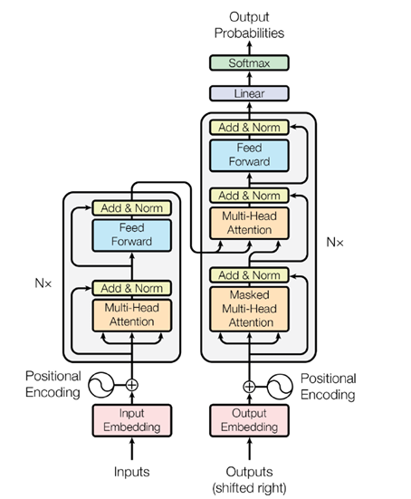
Figure 1. The architecture consists of an encoder and a decoder stack with multi-head attention, feed-forward layers, and positional encodings.

2.2.1. Limitations of Traditional Sequential Models
Prior to 2017, Recurrent Neural Networks (RNNs) and their more advanced variants, such as Long Short-Term Memory (LSTM) and Gated Recurrent Units (GRUs), were the dominant architectures for sequence processing tasks, including NLP. These models process input data sequentially, token by token, mimicking how a human might read a sentence. The hidden state at a given time step t is computed based on the input at step t and the hidden state from the immediately preceding step, t-1. While capable of handling sequences, this sequential architecture exhibits two severe, inherent technical limitations:
Difficulty in Capturing Long-Range Dependencies: As information must be passed sequentially through each time step, RNNs and LSTMs often struggle to maintain and link information between tokens that are far apart in a long sentence or paragraph. Technically, the phenomena of vanishing or exploding gradients during backpropagation cause information from the early steps to be either "forgotten" or distorted by the time the model processes the final steps. This significantly limits the ability to comprehend complex contexts, which often rely on long-distance informational dependencies.
Lack of Parallelizability: The sequential nature of RNNs/LSTMs poses a major computational performance bottleneck. The computation at step t is strictly dependent on the completion of the computation at step t-1. This dependency prevents the model from leveraging the power of modern parallel processors like Graphics Processing Units (GPUs). Consequently, the training process on large-scale datasets becomes extremely slow and inefficient, hindering the development of larger, more powerful models.

2.2.2. The Transformer Architecture and the Self-Attention Mechanism
To overcome these limitations, a novel architecture was proposed in the seminal 2017 paper, "Attention Is All You Need," by Vaswani et al. from Google [6]. This architecture, named the Transformer, revolutionized the field by completely eliminating the sequential recurrent structure. In its place, it introduced a groundbreaking core component that serves as the heart of the entire architecture: the Self-Attention Mechanism. Conceptually, Self-Attention allows the model, when processing a single token in an input sequence, to look at all other tokens in the same sequence simultaneously. It does not need to process them sequentially. Instead, it computes an "attention score" to quantify the relevance and semantic relationship between every pair of tokens in the sequence. Based on these scores, the model generates a more contextually rich vector representation for each token—a representation that is "informed" by all other tokens in the sentence [4]. To visualize this, consider the sentence "I kicked the ball". As illustrated in Figure 2, when the model processes the word "kicked," the Self-Attention mechanism calculates high attention scores linking it to "I" (the agent) and "ball" (the object), while assigning a very low score to the less informative word "the." This allows the model to understand who did what to whom.
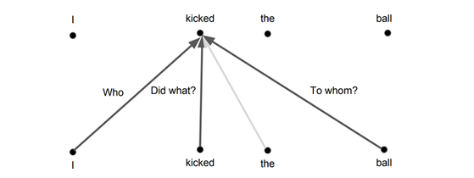
Figure 2 Self-Attention Illustration
Mathematically, this mechanism is realized through three learnable vectors for each input token: a Query (Q) vector, a Key (K) vector, and a Value (V) vector. These are generated by multiplying the input embedding of the token with three weight matrices (WQ, WK, WV) that are learned during training. The attention output for a given token is then calculated as a weighted sum of the Value vectors of all tokens in the sequence. The weights are determined by a compatibility function between the Query vector of the current token and the Key vectors of all other tokens. The most common implementation is the Scaled Dot-Product Attention, defined by the formula:
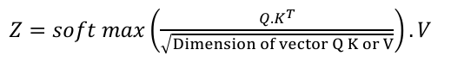(1)
The computation defined by Equation 1 proceeds through the following distinct steps:
Similarity Score Calculation: The initial step involves computing the dot product of the Query matrix Q with the transpose of the Key matrix K^T. This operation, Q·K^T, effectively calculates the similarity or compatibility score between every query vector and every key vector in the sequence. The resulting matrix contains raw, unnormalized attention scores, where a higher value indicates a stronger semantic relationship between the corresponding pair of tokens.
Scaling: The raw attention scores are then scaled down by dividing each element by √d_k, where d_k is the dimension of the key vectors. This scaling factor is a crucial normalization step. As Vaswani et al. (2017) noted, for large values of d_k, the dot products can grow very large in magnitude, pushing the softmax function into regions with extremely small gradients. This scaling helps to counteract that effect, leading to more stable training dynamics.
Weight Distribution via Softmax: A softmax function is applied to the scaled scores. This operation transforms the scores into a probability distribution, ensuring all values are non-negative and sum to 1. The output of the softmax function is a matrix of attention weights, where each weight represents the proportion of "attention" a given token should pay to every other token in the sequence.
Weighted Value Aggregation: Finally, the attention weights matrix is multiplied by the Value matrix V. This operation produces the final output vector for each token. It can be interpreted as a weighted sum of all value vectors in the sequence, where the weights are determined by the softmax scores. Effectively, this step aggregates information from the entire sequence, emphasizing tokens with high attention weights and diminishing those with low weights, thereby generating a highly context-aware representation for each token.

This entire computational process, performed in parallel for every token, directly gives rise to the superior advantages of the Transformer architecture:
Full Parallelizability: As the computation for each token does not rely on the output of a preceding token, the entire sequence can be processed concurrently. This architecture allows for maximum utilization of the parallel computing power of modern hardware like GPUs, drastically reducing training time and enabling the construction of much larger models.
Effective Handling of Long-Range Dependencies: The mechanism establishes direct connections between any two tokens in a sequence, with a constant path length of O(1). This definitively resolves the problem of capturing long-range semantic dependencies, a core weakness of sequential models where information has to propagate through many intermediate steps.
These two revolutionary advantages in computational performance and contextual modeling capability paved the way for training models of unprecedented scale on massive datasets. This was the direct precursor to the development of Large Language Models like BERT and GPT, and it marked the beginning of the generative AI revolution that is foundational to the technology employed in this thesis.

2.3. Large Language Models (LLMs)
The Transformer architecture, with its capabilities for parallel processing and effective context modeling, provided the technical prerequisites for researchers to train language models on an unprecedented scale. This led to the emergence of a new generation of models known as Large Language Models (LLMs), which are the core technology applied in this thesis. This section will define LLMs, analyze their characteristics, introduce prominent architectural examples, and critically examine their inherent limitations, thereby establishing the necessity for advanced customization techniques.

2.3.1. Definition, Characteristics, and Prominent Architectures
A Large Language Model (LLM) can be defined as a deep learning model based on the Transformer architecture, which has been pre-trained on a massive corpus of text data. This pre-training process, typically conducted via self-supervised learning tasks such as next-token prediction, allows the model to learn complex patterns of grammar, syntax, semantics, and a vast amount of general world knowledge.
The most notable characteristic of LLMs is the appearance of "emergent abilities"—capabilities to perform complex tasks for which they were not explicitly trained, such as question answering, text summarization, and logical reasoning. In practice, several prominent families of LLMs have been developed, each with distinct architectural approaches:
Encoder-only Architecture: The most representative example of this architecture is Google's BERT [5] (Bidirectional Encoder Representations from Transformers). As illustrated in Figure 3, BERT is fundamentally a stack of Transformer encoders. It is designed to "understand" language rather than "generate" it. By processing the entire input sentence at once (bidirectionally), BERT creates deep contextual representations for each token. Consequently, this architecture is extremely effective for Natural Language Understanding (NLU) tasks such as text classification, named entity recognition, and extractive question answering.
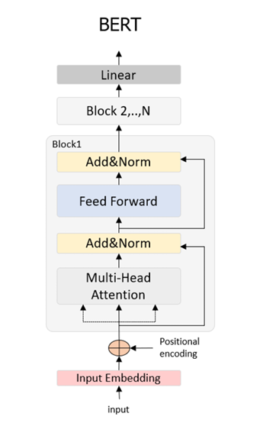
Figure 3. The architectural diagram of the BERT model
Decoder-only Architecture: In contrast to BERT, the GPT (Generative Pre-trained Transformer) series from OpenAI is the quintessential example of a decoder-only architecture. These models are optimized for text generation tasks. The launch of ChatGPT, based on the GPT-3.5 and GPT-4 models, demonstrated superior conversational and natural language generation capabilities, revolutionizing public perception of AI.
Encoder-Decoder Architecture: This is the original Transformer architecture, comprising both encoder and decoder stacks. It is highly suitable for sequence-to-sequence tasks such as machine translation (e.g., Google Translate) or text summarization.
The development of high-performance open-source models, particularly the Llama [3] series from Meta AI, has made the construction of specialized applications based on these architectures, such as the one in this thesis, more feasible and accessible.

2.3.2. Inherent Limitations of LLMs and the Need for Customization

Despite their remarkable capabilities, the direct application of off-the-shelf LLMs to real-world scenarios, especially those requiring high reliability and accuracy like admissions counseling, faces three severe and inherent challenges.
The "Hallucination" Phenomenon: This refers to the tendency of LLMs to generate text that is plausible and grammatically correct but is factually incorrect or nonsensical. In the context of admissions counseling, where a single piece of misinformation regarding admission scores or program codes can have serious consequences for an applicant's future, hallucinations are unacceptable.
The Knowledge Cutoff: The knowledge of an LLM is frozen at the point in time when its pre-training was completed. A model trained up to the end of 2023, for instance, would have no knowledge of Can Tho University's new admissions scheme for 2025, including new programs or updated criteria, rendering the model quickly obsolete.
Lack of Domain-specific Knowledge: LLMs are trained on general internet data and lack deep, specialized knowledge in niche domains. They are not specifically trained on the unique regulations, terminology, and administrative style of Can Tho University, which can lead to responses that are generic and lack precision.

2.4 Advanced Techniques for Optimizing LLMs for Practical Applications
Having identified the inherent limitations of off-the-shelf Large Language Models in section 2.3—including hallucination, knowledge cutoff, and a lack of domain-specific knowledge—this section will conduct an in-depth analysis of the advanced techniques proposed to directly overcome these issues. The application of these techniques is paramount to customizing and controlling an LLM, transforming it from a general-purpose tool into a reliable expert system for the admissions counseling task at Can Tho University. Fundamentally, after an LLM undergoes the pre-training phase on a massive dataset, it becomes a Foundation Model. To adapt this model for specific tasks, two primary approaches exist. The traditional approach is Fine-tuning, where the model is further trained to optimize for a specific task. However, a newer and more flexible approach, which does not require altering the model's weights, involves providing external knowledge to the model during inference, exemplified by the Retrieval-Augmented Generation (RAG) architecture. Figure 4 below illustrates this general workflow. This thesis will analyze and propose a hybrid approach that combines both of these advanced techniques.

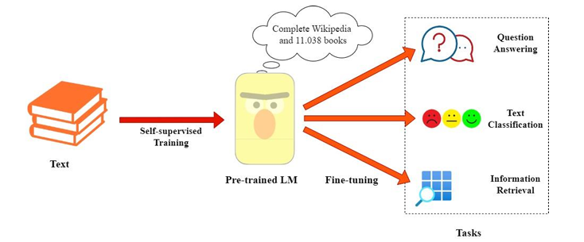
Figure 4. A general workflow from pre-training to application in specific tasks.

2.4.1. The Fine-tuning Technique
Principle:
Fine-tuning is a transfer learning method wherein a large, pre-trained model is further trained on a smaller, specialized, and labeled dataset. Instead of retraining the entire model from scratch—an extremely computationally expensive process—Fine-tuning only adjusts the model's weights to adapt it to the characteristics of the new data domain or a specific task.
Fine-tuning can be applied to numerous downstream tasks. Depending on the architecture of the base model (e.g., encoder-only like BERT or decoder-only like GPT), these tasks can be highly varied. Table 1 shows some examples of common fine-tuning tasks for these two model families.
Table 1. Comparison of GPT-3 and LLaMa 2 in Terms of Training Data and Token Count

Model | Database for training | Tokens
GPT3 | Common Crawl, Webtext2, Books,.. | 499 B
LlaMa 2 | CommonCrawl, Github, Books, Wikipedia,.. | 2000 B

Within the scope of this thesis, the primary objective of applying Fine-tuning is not to inject factual admissions knowledge into the model, as this is an inefficient and difficult-to-update method. Instead, the goal of Fine-tuning is to teach the model the conversational style and structure of admissions counseling. By fine-tuning on a curated dataset of question-answer pairs specific to Can Tho University's admissions, the model will learn the appropriate professional yet friendly tone, domain-specific terminology, and standard response structures. In other words, Fine-tuning helps the Chatbot to respond more naturally and appropriately.

2.4.2. The Retrieval-Augmented Generation (RAG) Technique
Principle:
Retrieval-Augmented Generation (RAG) [8] is a hybrid architecture specifically designed to address the critical LLM issues of hallucination and knowledge cutoff. Instead of relying solely on the internal knowledge encoded in its weights, a model in a RAG framework is given the ability to access an external, up-to-date knowledge base at inference time. The RAG process consists of two main stages:
Retrieve Stage: Upon receiving a user's query, the system uses it to search a trusted knowledge base (e.g., a repository of CTU's official admissions documents). The output of this stage is a set of context chunks that are most semantically relevant to the query.
Augmented Generation Stage: The retrieved context chunks are then incorporated into the prompt along with the original user query. The LLM receives a prompt in the format: "Based on the following information: [retrieved context], answer the question: [user's query]". With this provided context, the LLM acts as a reasoning and synthesis engine, generating a final answer that is grounded in the retrieved evidence.

The entire workflow of this architecture is illustrated in Figure 5 below.
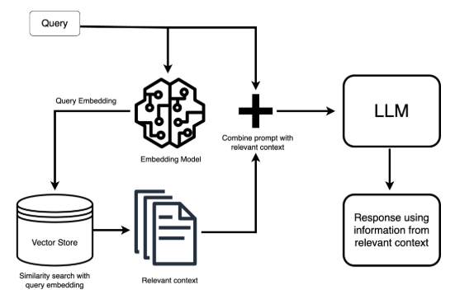
Figure 5. The workflow of the Retrieval-Augmented Generation (RAG) architecture.
As shown in the diagram, the process is initiated when a user submits a Query. This query is then processed along two parallel paths. First, it is passed to an Embedding Model, a specialized language model that converts the natural language text of the query into a high-dimensional vector representation known as a Query Embedding. This vector numerically captures the semantic meaning of the user's question. Simultaneously, this Query Embedding is used to perform a Similarity Search against a pre-indexed Vector Store (or Vector Database). This store contains the vectorized knowledge base of the university (e.g., every paragraph from the official admissions regulations). The search identifies and retrieves the document chunks whose embeddings are closest in the vector space to the Query Embedding, resulting in a set of Relevant Context. In the final stage, these retrieved context chunks are combined with the original, unprocessed Query to form an augmented prompt. This comprehensive prompt, which now contains both the user's question and the factual evidence needed to answer it, is fed to the LLM. The LLM then leverages its advanced reasoning and language capabilities to synthesize the provided information and generate a Response that is factually grounded in the relevant context, rather than relying solely on its internal, pre-trained knowledge.

2.4.3. Analysis of the Synergy between Fine-tuning and RAG: A Comprehensive Approach
While both Fine-tuning and RAG are powerful techniques for adapting LLMs, deploying either in isolation presents certain trade-offs. Fine-tuning is highly effective at aligning a model's behavior and response style to a specific domain, but it does not inherently solve the problem of factual grounding or knowledge updating. A fine-tuned model, while articulate, may still hallucinate or provide outdated information. Conversely, RAG excels at ensuring factual accuracy and currency by grounding the model's responses in an external knowledge base. However, if the foundational LLM has not been optimized for a specific conversational domain, its responses, though factually correct, may be overly generic, stilted, or fail to adopt the desired professional tone. Recognizing these complementary strengths and weaknesses, this thesis proposes a hybrid approach that integrates both techniques to create a more robust and effective system. This synergistic combination allows for the decoupling of two critical aspects of a sophisticated conversational agent: its knowledge base and its conversational skill.
The synergy can be conceptualized as follows:
RAG addresses the challenge of knowledge delivery ("what to say"). It functions as a dynamic, external knowledge source, equipping the LLM with the correct, verifiable, and up-to-date information needed to answer a query. This architectural component is primarily responsible for the accuracy, factuality, and reliability of the final response.
Fine-tuning addresses the challenge of stylistic alignment ("how to say it"). It adjusts the LLM's internal parameters to master the specific style, tone, and linguistic nuances of the target domain—in this case, the professional yet helpful persona of an admissions counselor. This component is responsible for the interaction quality, naturalness, and contextual appropriateness of the conversation.

By integrating both, the system can leverage a model that has been fine-tuned to communicate effectively, and then provide it with the precise, fact-based information retrieved by the RAG pipeline at the moment of inference. This dual optimization ensures that the final Chatbot system is capable of not only communicating naturally and professionally but also answering admissions queries with absolute accuracy and reliability, thereby achieving the ultimate objective of this thesis.and reliability, thereby achieving the ultimate goal of this thesis.

CHAPTER 3: DESIGN AND IMPLEMENTATION

3.1. System Architecture Design
To effectively implement the research objectives, a hybrid system architecture... is designed. Figure 6 provides a comprehensive schematic of this architecture, illustrating the entire workflow, which is logically divided into two distinct operational phases: the Offline Preparation Phase and the Online Inference Phase. The subsequent sections of this chapter will provide a detailed technical breakdown of each component and process shown in this diagram.
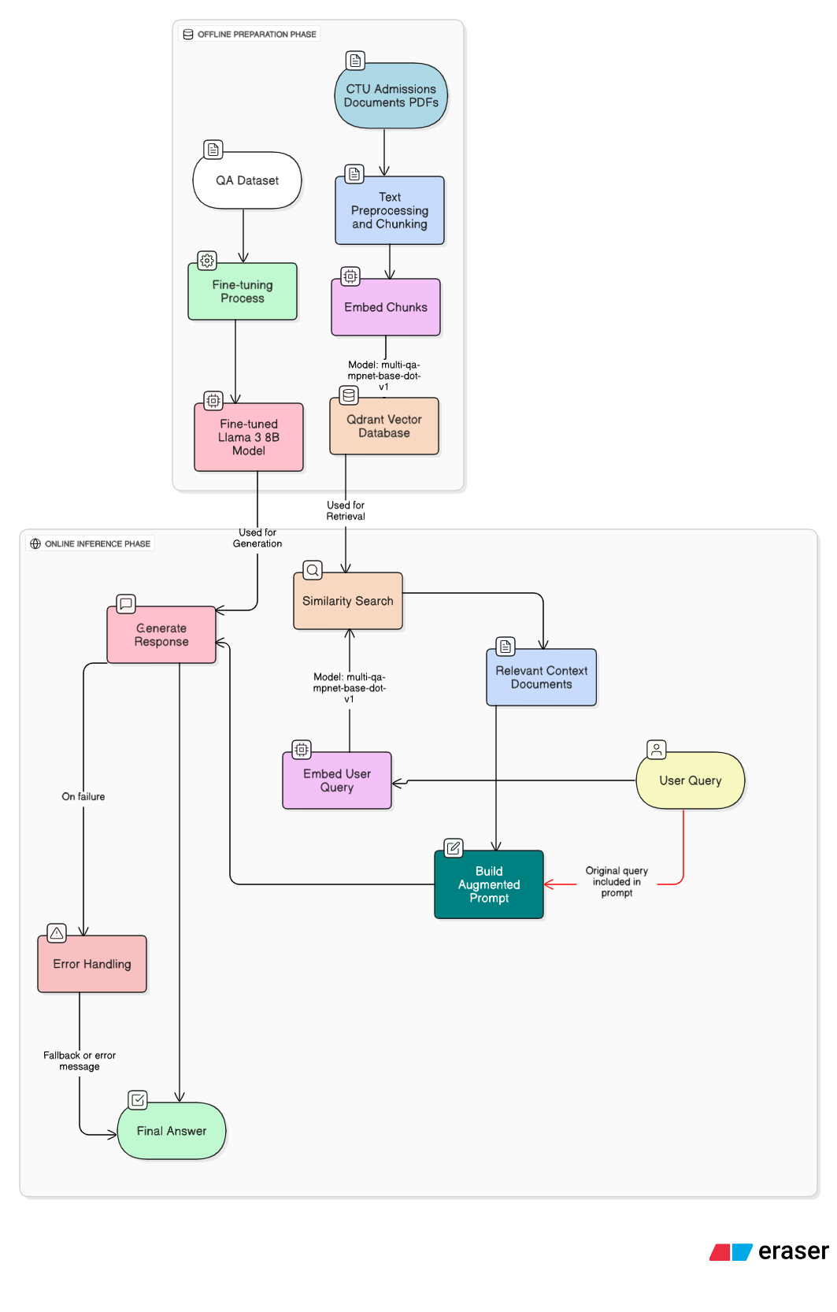
Figure 6. Overall System Architecture of the Hybrid Chatbot, illustrating the Offline Preparation and Online Inference Phases.

3.2. Technology Stack Selection and Experimental Environment
The selection of an appropriate technology stack is a critical step that directly influences the performance, scalability, and feasibility of the system. The choices for this project were guided by several key criteria: performance on relevant benchmarks, computational efficiency to match available resources, open-source licensing to allow for customization and on-premise deployment, and strong community support. This section details the specific technologies selected for each component of the architecture and describes the hardware environment used for development and experimentation.

3.2.1. Base Language Model
After evaluating several prominent open-source Large Language Models, Meta's Llama 3 8B was selected as the base model for the response generation module [3]. The Llama 3 series has demonstrated state-of-the-art performance on a wide range of industry benchmarks, showing significant improvements in reasoning and language nuance capabilities. The 8-billion-parameter variant was specifically chosen as it represents an optimal trade-off between high performance and manageable computational requirements. Its size allows for both efficient fine-tuning and inference on commercially available GPUs, which is a crucial factor for the project's resource constraints. Furthermore, its open-source nature grants the necessary flexibility for deep customization via fine-tuning and ensures data privacy by enabling local deployment.

3.2.2. Components of the Retrieval-Augmented Generation (RAG) System
Text Embedding Model:
For converting text chunks and user queries into dense vector representations, the multi-qa-mpnet-base-dot-v1 model from the Sentence-Transformers library was chosen. This model is specifically pre-trained on a massive dataset of question-answer pairs from diverse domains. Its training objective is optimized for semantic search tasks, where the goal is to produce embeddings such that the dot product similarity between a question and its correct answer is maximized. This characteristic makes it highly suitable for the retrieval task in this thesis.
Vector Storage and Retrieval Solution:
Qdrant was selected as the vector database for this project. Qdrant is a high-performance, open-source vector database specifically designed for large-scale similarity search applications. For this project, a cloud-hosted instance of Qdrant was utilized, which ensures high availability and scalability without the need for manual infrastructure management. Its key advantages include efficient filtering capabilities, a robust API—accessed via the official qdrant-client library—and optimized indexing algorithms. During the collection setup, Cosine Similarity (Distance.COSINE) was chosen as the distance metric. This metric is particularly effective for normalized text embeddings as it measures the cosine of the angle between vectors, focusing on orientation rather than magnitude, which is a better proxy for semantic similarity.

3.2.3. Development Framework and Core Libraries
The implementation of the system was primarily conducted in the Python 3.10 programming language, chosen for its extensive and mature ecosystem of libraries for data science, machine learning, and web development. To ensure reproducibility and manage dependencies, all libraries were managed within a virtual environment. The selection of core frameworks and libraries was pivotal to streamlining the development of the complex RAG and Fine-tuning pipelines.
The key components of the development stack are detailed below:
PyTorch: As the foundational deep learning framework, PyTorch was utilized for all tasks involving neural network computations. Its dynamic computation graph and extensive support for GPU acceleration were essential for both the fine-tuning process of the Llama 3 model and for running inference on the embedding models.
Hugging Face Transformers: This library served as the primary interface for accessing and manipulating the pre-trained Llama 3 8B model. It provided high-level APIs for model loading, tokenization, and the execution of the fine-tuning training loop, significantly abstracting away the underlying complexity.
Hugging Face Sentence-Transformers: This library was specifically used to load and interact with the multi-qa-mpnet-base-dot-v1 embedding model. It offers a simplified interface for generating high-quality sentence and text embeddings, which is a cornerstone of the retrieval module.
LangChain: This framework was employed as a high-level orchestration tool to structure and connect the various components of the RAG pipeline. Its modular design facilitated the implementation of the end-to-end inference chain, from document loading and chunking, to building the augmented prompt template, and finally to interacting with the fine-tuned LLM.
Qdrant-client: The official Python client library for the Qdrarnt vector database. This library was used to programmatically create and manage the vector collection, ingest the vectorized document chunks, and execute real-time similarity search queries.
FastAPI: To expose the functionality of the Chatbot as a web service, FastAPI was chosen as the API framework. It is a modern, high-performance web framework for building APIs with Python, known for its speed, automatic interactive documentation (via Swagger UI), and ease of use.

3.2.4. Hardware and Cloud Computing Environment
All computationally intensive tasks, including model fine-tuning and inference experiments, were conducted on a cloud-based GPU instance provisioned from the RunPod.io platform. The use of a cloud computing environment was chosen to gain access to enterprise-grade GPUs and to ensure a scalable and reproducible experimental setup.
The specific "Pod" configuration utilized for this research is summarized as follows:
- Graphics Processing Unit (GPU): 1x NVIDIA RTX A4500
- Video RAM (VRAM): 20 GB GDDR6
- Virtual CPUs (vCPU): 12 vCPUs
- System Memory (RAM): 62 GB
- Storage: 80 GB of Disk Space
The selection of the NVIDIA RTX A4500 GPU was a critical factor, as its 20 GB of VRAM provided the necessary capacity to load the Llama 3 8B model and execute the fine-tuning process without encountering out-of-memory errors. This cloud-based configuration provided the requisite computational power to efficiently conduct the experiments outlined in this thesis.

3.3. Offline Preparation Phase: Data Curation and Model Training

3.3.1. Knowledge Base Construction:
The construction of a comprehensive and trustworthy knowledge base is the cornerstone of the RAG system. This process involves a multi-stage data engineering pipeline designed to transform unstructured documents from Can Tho University into a structured, efficiently searchable vector store. The data acquisition process focused on aggregating information from official sources related to Can Tho University. The primary sources were the official university portal (https://www.ctu.edu.vn/), the specialized admissions portal (https://tuyensinh.ctu.edu.vn/), and a collection of official documents in PDF and DOCX format, including the annual admissions scheme and academic regulations. The automated data collection from websites was performed using Crawl4AI. Following aggregation, the raw data was subjected to a meticulous cleaning pipeline. A key challenge was the extraction of structured information, such as major names, from inconsistent filenames. To address this, a specialized function was developed that combined manual mapping for known complex cases with pattern matching for standardized names. Furthermore, the system was designed to not only extract plain text but also to identify and parse tabular data within DOCX files. All documents were then converted into a uniform plain text format, and a series of functions using Python's regular expression library (re) were applied to remove non-informational artifacts. The final cleaned data was structured and saved into a processed_data_rag.json file, with texts pre-categorized to facilitate the subsequent multi-collection indexing strategy. After the cleaning process, the next critical step is Text Chunking. A sophisticated chunking strategy was employed to handle the heterogeneity of the data. For standard prose, a Recursive Character Text Splitter from the LangChain framework was used. A chunk_size of 1000 characters and a chunk_overlap of 200 characters were empirically chosen to balance context richness with retrieval precision. For tabular data extracted from documents, each table was treated as a single, distinct chunk and tagged with specific metadata (type: "table"). This hybrid strategy ensures that structured tabular information is not fragmented and that prose is segmented in a semantically coherent manner. The final stage involves transforming the text chunks into a machine-readable format and organizing them for rapid retrieval. To optimize retrieval relevance, a multi-collection strategy was adopted. Based on the pre-categorization from the cleaning step, the data was indexed into three separate, topic-specific collections within Qdrant: ctu_faculty_majors, ctu_admission_process, and ctu_general_info. Each text chunk was then passed through the pre-trained multi-qa-mpnet-base-dot-v1 embedding model to generate a 768-dimensional vector embedding.
The ingestion process was optimized for performance and stability. The vectorization was performed in batches of 32, and the subsequent upsert operation to the Qdrant Cloud instance was performed in batches of 100 points. Each point stored in Qdrant contains not only the vector but also a rich metadata payload, including the source filename and the original text content. This process results in a fully indexed and searchable vectorized knowledge base, serving as the factually grounded memory for the chatbot.

3.3.2. Fine-tuning process:
While the RAG mechanism provides the system with factual knowledge, the fine-tuning process is essential for shaping the model's conversational behavior and aligning its response style with the intended persona of a professional university counselor. This section details the two key stages of this process: the curation of a specialized dataset and the execution of the fine-tuning training loop.
Fine-tuning Dataset Curation
To effectively teach the Llama 3 8B model the desired communication style, a high-quality, specialized instruction dataset was manually curated. A manual approach was chosen over automated methods to ensure the highest degree of relevance, accuracy, and stylistic consistency in every training example. The dataset was constructed as a collection of approximately 5000 question-and-answer pairs and was subsequently split into a training set and a validation set to monitor for overfitting. Each sample in the dataset was structured in a JSONL format and formatted into a unified text field following a specific instruction template, which clearly delineates the roles of the user and the assistant and instructs the model on its task.
Model Fine-tuning Execution Process
The execution of the fine-tuning process was performed on the cloud-based GPU environment detailed in Section 3.2.4. To optimize for memory efficiency and training speed, the Unsloth library, a high-performance implementation for fine-tuning LLMs, was utilized.
Model Preparation and Parameter-Efficient Fine-Tuning (PEFT):
The base model, unsloth/llama-3-8b-instruct-bnb-4bit, was loaded in 4-bit precision. To make the training computationally feasible on the available hardware, a QLoRA (Quantization and Low-Rank Adaptation) [7] strategy was employed. The FastLanguageModel class from Unsloth was used to configure the PEFT adapters. Low-rank adapters were attached to the key linear layers of the Transformer architecture, including the query (q_proj), key (k_proj), value (v_proj), and output (o_proj) projection layers. The key hyperparameters for QLoRA were set as follows: r (LoRA rank) = 32 and lora_alpha = 64. This configuration resulted in a small fraction of the total parameters being trainable, significantly reducing memory requirements.
Data Tokenization and Masking:
The training and validation datasets were tokenized with a maximum sequence length set to 2048 tokens. A critical step in preparing the data for instruction-tuning is loss masking. To ensure the model only learns to predict the assistant's response, the tokens corresponding to the user's question in the labels were masked with a value of -100, so they are ignored by the loss function during backpropagation.
Training and Hyperparameters:
The model was trained using the Trainer class from the Hugging Face transformers library for 3 epochs. Key hyperparameters include a learning rate of 3e-5 and an effective batch size of 16 (achieved with a per-device batch size of 2 and 8 gradient accumulation steps). An EarlyStoppingCallback with a patience of 3 was also used to prevent overfitting. The entire training process was completed in approximately 6 hours. The resulting training and validation loss curves, which are critical for evaluating the training process, are presented and analyzed in detail in Chapter 4. The final fine-tuned adapter weights, which are lightweight and portable, were saved to the output directory for integration into the final inference pipeline. A summary of the key hyperparameters used during the training process is provided in Table 2.

Table 2. Key Fine-tuning Hyperparameters
Hyperparameter | Value
Base Model | unsloth/llama-3-8b-instruct-bnb-4bit
Technique | QLoRA (4-bit)
Learning Rate | 3e-5
Epochs | 3
Batch Size | 2
Gradient Accumulation | 8
Max Sequence Length | 2048
Optimizer | AdamW
Warmup Ratio | 0.03
LoRA Rank (r) | 32
LoRA Alpha | 64
LoRA Dropout | 0.1

3.4. Online Inference Phase: The Real-time Processing Pipeline
This section describes the end-to-end, real-time pipeline that executes when a user interacts with the Chatbot. This is the "online" phase where the data assets and the specialized model prepared in the offline phase are orchestrated to deliver a timely and accurate response. The pipeline is composed of several interconnected modules, each performing a specific function in the sequence from query ingestion to final answer generation.

3.4.1. Context Retrieval Module:
The primary responsibility of this module is to retrieve relevant factual information from the knowledge base that can be used to answer the user's query. This process is the core of the RAG system's "retrieval" stage and consists of two sequential steps:
Query Embedding:
When a user query is received by the system, it is first passed through the same multi-qa-mpnet-base-dot-v1 model that was used to vectorize the document chunks. This crucial step ensures that the user's query and the documents exist within the same semantic vector space, which is essential for accurate similarity comparison. The output of this step is a 768-dimensional query vector that numerically represents the user's informational need.
Similarity Search:
This query vector is then used to query the Qdrant vector database. The module executes a high-speed similarity search, using Cosine Similarity as the distance metric, to find the top-k most similar document chunks from the indexed knowledge base collections. The text content of these chunks is then returned as the context for the next module. After empirical testing, a k value of 4 was chosen, as it was found to provide a sufficient amount of context for the LLM to form a comprehensive answer without exceeding the model's context window or introducing excessive noise.

3.4.2. Augmented Response Generation Module:

This module is responsible for synthesizing the retrieved context and the user's query into a final, factually grounded, and stylistically appropriate answer.

Prompt Engineering
A carefully designed prompt template is essential to guide the LLM's generation process effectively. The template explicitly instructs the model on its role, its constraints (e.g., to only use the provided context), and the format of the inputs. The final prompt is constructed by dynamically inserting the retrieved context from the previous module and the original user query into this template. The template used in this system is shown in Figure 7.

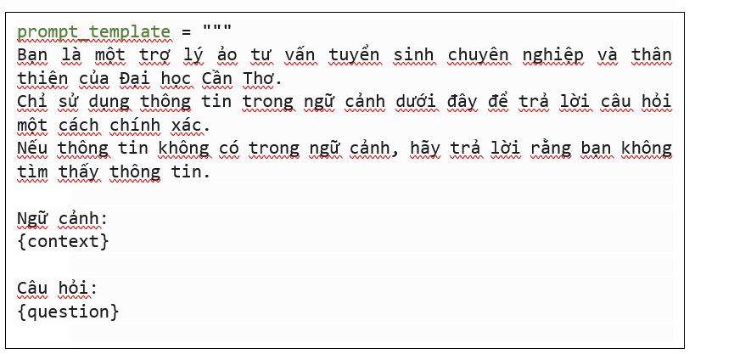
Figure 7. Prompt Template for Augmented Generation

Response Generation with the Fine-tuned Model

The augmented prompt, now rich with factual context, is passed as input to the fine-tuned Llama 3 8B model. The use of this specific model is a deliberate design choice that actualizes the synergy of the hybrid approach. The RAG-provided context ensures the response is factually grounded, while the model's fine-tuning ensures the response is delivered in a natural, helpful, and stylistically appropriate manner, consistent with the persona of a university counselor. The model leverages its advanced reasoning capabilities to synthesize an answer based on the provided context, completing the core logic of the pipeline.

3.4.3. User Interface and Error Handling:
User Interaction Interface:
To provide an accessible and intuitive way for users to interact with the chatbot, a simple web-based user interface was developed. The interface was built using the Streamlit library in Python, chosen for its ability to rapidly create data-centric web applications. The interface, as shown in Figure 8, provides a familiar, minimalist chat-style layout. It features a text input box at the bottom where users can type their questions. Upon submission, the query is sent via an HTTP request to the FastAPI backend, which executes the entire online inference pipeline. The final generated response is then streamed back to the user interface. Figure 3.Y further demonstrates the interface in action, showing a well-formatted and informative response to a more complex query, complete with source attribution which enhances user trust and transparency.
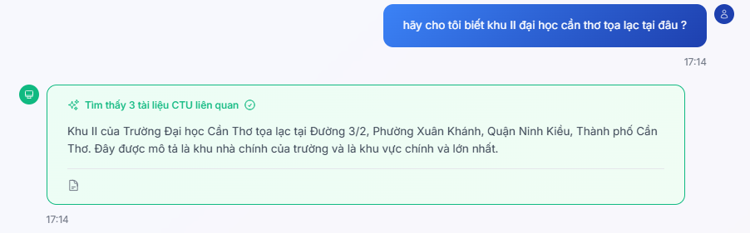
Figure 8. The basic layout of the user interface showing a simple query and response
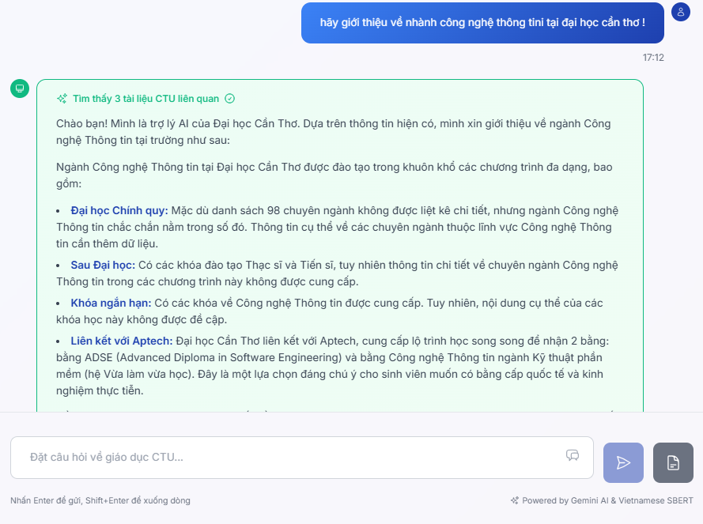
Figure 9. The interface displaying a detailed, multi-paragraph response to a comprehensive query.

Failure Case and Error Handling:
In a real-world application, system failures such as API timeouts, resource limitations, or unexpected errors in the generation pipeline can occur. To prevent a poor user experience caused by the system crashing or becoming unresponsive, a basic error handling mechanism was implemented. If the response generation module fails to produce a valid output within a specified timeout or encounters an unhandled exception, the system is designed not to crash. Instead, it gracefully catches the exception and returns a pre-defined, user-friendly fallback message. As illustrated in Figure 10, this ensures that the user is always provided with a clear and polite notification of the issue, such as "Xin lỗi, có lỗi xảy ra khi xử lý câu hỏi của bạn. Vui lòng thử lại sau." (Sorry, an error occurred while processing your request. Please try again later.). This approach ensures a graceful failure mode, maintains a professional user experience, and contributes to the overall robustness of the system.


Figure 10. The chatbot's response during a system failure at server, demonstrating the graceful error handling mechanism.

CHAPTER 4: EVALUATION

4.1. Evaluation Methodology
To rigorously validate the system, a multi-faceted evaluation protocol was designed, combining both automated metrics and human-centric assessment. A specialized test dataset was curated, comprising 100 unique questions categorized into key admissions topics (e.g., academic programs, policies, financial information). For each question, a ground-truth answer was compiled from official source documents to serve as a benchmark.
Proposed System: The complete hybrid system combining the fine-tuned Llama 3 8B model with the RAG pipeline. Each of the 100 test questions was fed into all three systems. The generated responses were then assessed against the ground-truth answers using two sets of metrics: Quantitative Metrics (Precision, Recall, F1-Score, BLEU Score) for automated measurement of accuracy and fluency, and Qualitative Criteria (Factual Accuracy, Usefulness Score on a 5-point scale) for manual human evaluation.

4.2. Results and Analysis
This section presents the comprehensive evaluation results for the final, integrated system, which combines Retrieval-Augmented Generation (RAG) with the fine-tuned Llama 3 8B model. The performance was assessed using both the automated metrics and the qualitative criteria defined in the methodology.

4.2.1. Fine-tuning Process Stability
The stability and effectiveness of the fine-tuning process were evaluated by monitoring the training and validation loss. Figure 11 displays the loss curves generated during the 6-hour training run.
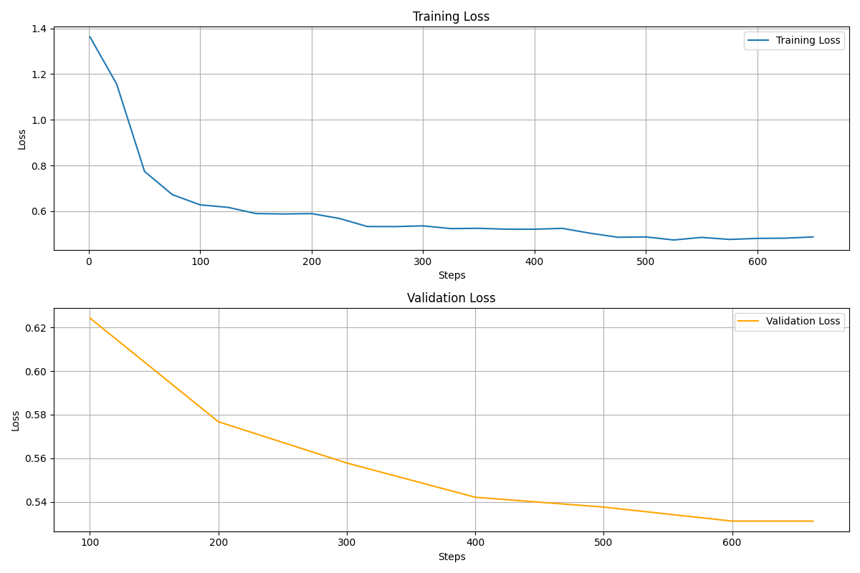
Figure 11. Training and Validation Loss Curves for the Llama 3 8B Fine-tuning Process.
The training loss curve demonstrates a desirable convergence pattern, decreasing sharply before stabilizing at a low value. Crucially, the validation loss curve shows a consistent downward trend, indicating that the model generalized well to unseen data and did not suffer from overfitting. This confirms the success of the fine-tuning process, resulting in a robust model for the subsequent inference pipeline.

4.2.2. System Performance Evaluation
The final hybrid system was rigorously tested against the curated evaluation dataset. The results from both the manual (qualitative) and automated (quantitative) assessments are presented below.

1. Manual Evaluation Results:
The qualitative assessment, conducted by a group of subject-matter experts, focused on the practical utility and reliability of the chatbot's responses. The key findings were as follows:
Factual Accuracy: The chatbot achieved a high accuracy rate of 95% in correctly answering the test questions when compared against the ground-truth information.
Response Consistency: The system demonstrated high stability, maintaining a consistency rate of over 98% when asked the same questions in repeated trials.
Usefulness Score: Feedback from the expert group indicated that the chatbot's answers were highly useful and effectively met user information needs. The system achieved an average usefulness rating of 4.5 out of 5.

2. Automated Evaluation Results:
The quantitative metrics provide further objective insight into the system's performance. The scores, calculated programmatically, are summarized in Table 3 [9].
Table 3. Automated Evaluation Metrics for the Proposed System
Metric | Score
Precision | 0.90
Recall | 0.95
F1-Score | 0.90
BLEU Score | 0.90

3. Discussion of Results:
The combined results confirm the viability and effectiveness of the proposed hybrid architecture. The high scores across both manual and automated evaluations demonstrate the system's ability to provide responses that are not only factually accurate but also contextually appropriate and linguistically fluent.
The high Factual Accuracy (95%), Precision (0.90), and Recall (0.95) scores strongly suggest that the RAG pipeline is highly effective at retrieving the correct context and that the system successfully mitigates the risk of hallucination. The strong Usefulness Score (4.5/5) and BLEU Score (0.90) indicate that the fine-tuning process was successful in aligning the model's output to a natural and helpful conversational style. In conclusion, these metrics indicate that the chatbot is capable of providing correct and contextually appropriate answers in the vast majority of cases. However, as a final step before full-scale deployment, it is recommended to conduct end-user testing to gather feedback on user satisfaction. This feedback can be used to further optimize the model's parameters and prompt templates to achieve the highest level of performance in a practical setting.

CHAPTER 5: CONCLUSION AND FUTURE WORK

5.1. Conclusion
This thesis embarked on the task of developing an intelligent chatbot to address the challenges in admissions counseling at Can Tho University. The initial investigation in Chapter 1 identified significant gaps in the existing counseling methods, highlighting a critical need for a solution that is accurate, instantly available, and scalable. In response, Chapter 2 established a robust theoretical foundation, surveying the evolution from traditional NLP models to the revolutionary Transformer architecture and the subsequent rise of Large Language Models (LLMs). Crucially, this chapter analyzed the inherent limitations of LLMs, such as hallucination and knowledge cutoffs, thereby justifying the adoption of a hybrid approach. Following the theoretical groundwork, Chapter 3 detailed the design and implementation of a hybrid system architecture. This system synergistically combines Retrieval-Augmented Generation (RAG) to ensure factual grounding with a fine-tuned Llama 3 8B model to achieve a natural, domain-specific conversational style. The chapter provided a comprehensive account of the entire development pipeline, from data engineering and model training in the offline phase to the real-time inference process. Finally, Chapter 4 presented a rigorous empirical evaluation of the developed system. The experimental results provided strong evidence for the efficacy of the proposed solution. The fine-tuning process was shown to be stable and effective, and the final hybrid system demonstrated superior performance, achieving a factual accuracy rate of 95% and a high user-rated usefulness score of 4.5 out of 5. These results confirm that the system successfully meets the primary research objectives, delivering responses that are both highly reliable and conversationally appropriate.

5.2. Contributions of the Thesis
This research makes several key contributions to both academic and practical domains:
In terms of practical application, this thesis delivers a functional prototype of an intelligent admissions counseling chatbot specifically tailored for Can Tho University. This system has the potential to significantly enhance the efficiency of the admissions office by automating responses to common queries, while simultaneously improving the experience for prospective students by providing instant, 24/7 access to reliable information. In terms of technical contribution, the project provides a detailed case study on the successful implementation of a hybrid RAG and Fine-tuning architecture. It presents a complete and replicable workflow—encompassing data processing, parameter-efficient fine-tuning using QLoRA, and system deployment—that can serve as a blueprint for developing similar domain-specific conversational AI systems in other educational institutions. In terms of academic contribution, the thesis empirically validates the hypothesis that the synergistic combination of RAG and fine-tuning is a superior approach for building factual and natural conversational agents. The evaluation clearly demonstrates that this hybrid model overcomes the individual weaknesses of using either technique in isolation.

5.3. Limitations of the Thesis
Despite the positive results, this research is subject to several limitations that should be acknowledged:
Knowledge Base Coverage: Although efforts were made to collect data from official sources, the knowledge base for the RAG system is not yet exhaustive. This limitation can sometimes lead to the system's inability to find relevant context for highly specific or newly emerged queries.
Conversational Context and Memory: The current system primarily handles single-turn, independent questions. It lacks a conversational memory, which prevents it from understanding follow-up questions that depend on the context of the preceding conversation.
Response Latency: As the system was deployed in an experimental environment with limited resources, the response time has not been fully optimized for a large-scale, production setting.
Personalization: The system currently provides the same information to all users. It lacks the capability to offer personalized advice based on a specific user's academic profile (e.g., their exam scores or subject combination).
Residual Hallucination: While the RAG architecture significantly mitigates hallucinations, the system may still generate contextually incorrect or subtly inaccurate details when the retrieved context is ambiguous or incomplete, highlighting its heavy reliance on the quality of the retrieval stage.

5.4. Future Work
Based on the limitations identified, several promising directions for future research and development are proposed:
Expansion and Automation of the Knowledge Base: To build a semi-automated pipeline that periodically crawls for new announcements on the university's website and updates the vector database, ensuring the chatbot's knowledge is always current.
Integration of Conversational Memory: To research and implement memory management techniques to enable the chatbot to handle multi-turn dialogues, creating a more natural and coherent user experience.
Performance Optimization: To explore and implement advanced inference optimization techniques, such as model quantization or frameworks like vLLM, to significantly reduce response latency and improve the system's capacity to handle concurrent users.
Advanced Retrieval Strategies: To enhance the RAG pipeline by applying more sophisticated retrieval techniques. This could include using a cross-encoder model for re-ranking retrieved documents or implementing an iterative retrieval process to handle complex, multi-faceted queries more effectively [10].
Development of Personalization Capabilities: To build a module that allows users to input their personal academic information, enabling the system to provide tailored advice and personalized guidance on suitable academic programs and their admission prospects.

REFERENCES
[1] Can Tho University, "Official Website of Can Tho University," 2025. [Online]. Available: https://www.ctu.edu.vn/
[2] University of Economics Ho Chi Minh City. (2023). Launch of UEH AI Chatbot Virtual Assistant - Applying artificial intelligence for admissions and career counseling for parents and students
[3] Meta AI, "Introducing Meta Llama 3: The most capable openly available LLM to date," Meta AI Blog, Apr. 2024.
[4] Minh-Thang Luong, Hieu Pham, and Christopher D Manning. Effective approaches to attentionbased neural machine translation. arXiv preprint arXiv:1508.04025, 2015.
[5] J. Devlin, M.-W. Chang, K. Lee, and K. Toutanova, "BERT: Pre-training of deep bidirectional transformers for language understanding," arXiv preprint arXiv:1810.04805, 2018.
[6] A. Vaswani, N. Shazeer, N. Parmar, J. Uszkoreit, L. Jones, A. N. Gomez, Ł. Kaiser, and I. Polosukhin, "Attention is all you need," in Advances in Neural Information Processing Systems, vol. 30, 2017.
[7] E. J. Hu, Y. Shen, P. Wallis, Z. Allen-Zhu, Y. Li, S. Wang, L. Wang, and W. Chen, "LoRA: Low-rank adaptation of large language models," arXiv preprint arXiv:2106.09685, 2021.
[8] Y. Gao, Y. Xiong, X. Gao, K. Jia, J. Pan, Y. Bi, Y. Dai, J. Sun, and M. Guo, "Retrieval-augmented generation for large language models: A survey," arXiv preprint arXiv:2312.10997, 2023.
[9] S. Es, J. de Wit, J. Ramos, and M. de Rijke, "RAGAs: Automated evaluation of retrieval augmented generation," arXiv preprint arXiv:2309.15217, 2023.
[10] A. Asai, Z. Wu, Y. Wang, A. Sil, and H. Hajishirzi, "Self-RAG: Learning to retrieve, generate, and critique through self-reflection," arXiv preprint arXiv:2310.11511, 2023

